Commentary

Feb 21, 2025

Arab News

**Vienna Process Offers a Genuine Alternative to the Taliban** 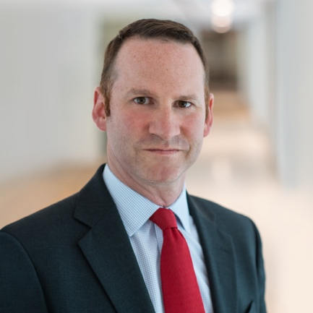

[Luke Coffey](https://www.hudson.org/experts/1453-luke-coffey)

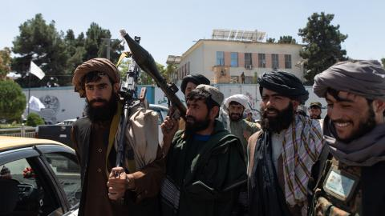

Caption

Taliban supporters parade through the streets of Kabul on August 15, 2023, in Kabul, Afghanistan. (Nava Jamshidi via Getty Images)

This week, more than 100 Afghans from different ethnic and minority groups gathered in Vienna, Austria, for the fifth meeting of the Vienna Process for a Democratic Afghanistan. Over the past two years, the Vienna Process has emerged as the primary forum for anti-Taliban resistance movements to coordinate, strategize, and chart a common path forward. While the international community has struggled to formulate a coherent approach to Afghanistan, this growing coalition of opposition groups has steadily built a framework for an alternative future.

The Vienna Process has grown in both scope and influence since its inception in September 2022, one year after the Taliban’s return to power. The first round brought together over 30 participants from various Afghan minority and ethnic groups, who issued a joint statement rejecting Taliban rule as unacceptable. Perhaps the most significant outcome was the emergence of Ahmad Massoud, the son of famed anti-Taliban commander Ahmad Shah Massoud, as the de facto leader of the resistance.

By April 2023, the second round had expanded to include a broader range of activists, representing diverse ethnic, religious, and political backgrounds. While Massoud and the National Resistance Front remained central, the Ankara Coalition, Hazara, and Uzbek representatives played key roles. Notably, nearly half of the participants were women. This time, they took a bolder step, agreeing to support all forms of resistance against the Taliban, including armed struggle.

The third round in December 2023 saw even greater participation, with over 50 representatives from anti-Taliban groups. For the first time, Abdul Rashid Dostum, an Uzbek commander and longtime Afghan powerbroker, sent a personal envoy. The presence of international observers from the US and Europe signaled a growing recognition of the resistance movement.

By June 2024, the fourth round had grown to 70 participants, including influential figures such as former Afghan Vice President Yunus Qanuni; Hazara leader Mohammad Mohaqiq; and Anarkali Honaryar, an Afghan Sikh. Women’s rights activist Parwana Ibrahimkhel, who had been imprisoned by the Taliban in 2022, also joined. To develop a roadmap for Afghanistan’s future, participants broke into working groups focused on politics, foreign policy, human rights, and economics.

This week’s fifth round was even larger and included almost 100 attendees. For the first time, there was a session giving international observers from the US and Europe an opportunity to speak and engage. In addition to Ahmad Massoud, other notable attendees included Yasin Zia, leader of the Afghanistan Freedom Front; and Rangin Dadfar Spanta, the country’s former national security adviser.

The biggest outcome of this meeting was the agreement to a roadmap that various working groups had been drafting since the last meeting in June. This program is the opposition’s attempt at showing that there is an alternative to the current Taliban rule. All aspects of Afghanistan’s future and society are covered to include future economic development, security, diplomatic relations, and human rights, with a special emphasis on women’s rights.

A special commission of 19 members representing all walks of Afghan society was also formed. This commission will work together and coordinate a response to implement the roadmap.

At the heart of the Vienna Process is Massoud. Since fleeing to his ancestral homeland in the Panjshir Valley, north of Kabul, Massoud has pursued a dual-track approach to countering the Taliban. Militarily, the NRF is active in many provinces across Afghanistan, primarily in the north, using guerrilla warfare tactics to target Taliban forces. Last year alone, the NRF launched dozens of attacks, making it a persistent security challenge for the Taliban. Diplomatically, Massoud has led an international effort to raise awareness of the resistance and build alliances. This is one of the main reasons the Vienna Process has gained momentum.

The Vienna Process offers a rare good news story about Afghanistan. Since the Taliban returned to power in 2021, they have shown little ability to govern effectively. The country faces an acute humanitarian crisis that worsens each year, and the economic situation remains dire as questions arise over the sustainability of international aid. Meanwhile, human rights conditions continue to deteriorate, with ethnic minorities persecuted, girls banned from schools, and women forced out of many workplaces. Yet, the NRF and other Vienna Process participants demonstrate that an alternative future is possible. The situation today mirrors the 1990s when the Northern Alliance controlled only 10 percent of Afghanistan, yet refused to surrender to the Taliban. Likewise, the NRF and other resistance groups must continue their fight and ensure that the world does not forget them.

The Taliban itself is deeply divided, with competing factions vying for power. These internal fractures could create opportunities for the anti-Taliban resistance to establish safe zones and reclaim territory. The international community would be wise to engage more seriously with the Vienna Process. While a few international observers attended this week’s meeting, no senior government officials participated. At the next Vienna Process gathering, representatives such as the US special envoy for Afghanistan and counterparts from other nations should attend — even if only as observers. It makes little sense that much of the international community engages with the Taliban as the de facto rulers of Afghanistan, while failing to establish meaningful dialogue with resistance movements such as the NRF and others in the Vienna Process.

With each round, the Vienna Process has become more inclusive and strategic, positioning itself as the most significant platform for Afghanistan’s anti-Taliban resistance. Global policymakers should take note.

[Read in *Arab News*](https://www.arabnews.com/node/2591095).